 | Bansilal Ramnath Agarwal Charitable Trust’s Vishwakarma Institute of Information Technology  Department of  Artificial Intelligence and Data Science
Student Name: Sathe Onkar Abasaheb
Class: TY | Division: B |  | Roll No.: 372078
Semester: V |  | Academic Year: 2025-2026
Subject Name & Code: Cyber Security (AD31234B)
Assignment No: 01
Title of Assignment: Study different types of Attacks as a part of awareness: Phishing,
Ransomware and Supply-Chain attack.

Date of Performance: 14/07/2025 |  | Date of Submission: /07/2025

Assignment 1: Study different types of Attacks as a part of awareness: Phishing, Ransomware and Supply-Chain attack.

Objective:
To understand and analyze various types of cyber-attacks: Phishing, Ransomware, and Supply Chain Attacks and to create awareness about how these attacks work, their impact, and prevention techniques.

Materials Required:

Computer with internet access

Introduction:
- Phishing
Phishing is a cyberattack method that uses social engineering techniques to deceive users into providing confidential information such as usernames, passwords, credit card numbers, or personal details. Attackers often impersonate legitimate institutions (banks, government bodies, or popular platforms like Google or Amazon) to gain the victim’s trust.

Key Characteristics of Phishing:
- Deceptive communication (email, SMS, calls)
- Use of fake websites or login pages
- Exploits human psychology (urgency, fear, curiosity)
- Aims to steal sensitive data or install malware

Types of Phishing
- Email Phishing: Broadly distributed emails mimicking reputable organizations, like banks or retailers, enticing users to click harmful links or share confidential data.
- Spear Phishing: Customized attacks targeting specific individuals or companies, using tailored details (e.g., from LinkedIn or corporate sites) to enhance authenticity.
- Smishing: Phishing through text messages, delivering malicious links or prompts for sensitive information.
- Vishing: Phone-based phishing where attackers impersonate credible sources, such as government officials or company representatives, to extract data.

Example of a Phishing Email:
Subject: Urgent Security Alert – Verify Your Account Now
From: support@bankofamerica-secure.com
Dear Customer,
We noticed suspicious activity on your account. Please verify your identity immediately to prevent suspension.
Click here to secure your account: http://bank-verify-login.com
Regards,
Bank of America Security Team
Phishing Indicators:
- Generic greeting (e.g., "Dear Customer" instead of your name)
- Urgent language (e.g., "immediate action required")
- Suspicious links (hover to reveal mismatched URLs)
- Poor grammar or spelling mistakes
- Unexpected attachments
- Sender address mismatch (e.g., support@bankofamerica-secure.com is not official)

Real-World Examples of Phishing Attacks:

- Google & Facebook Scam (2013–2015):
- Attacker: Evaldas Rimasauskas
- Method: Fake invoices and emails pretending to be from Quanta (a vendor)
- Impact: $100+ million stolen from Google and Facebook


(Figure 1a: Money phishing with messenger)

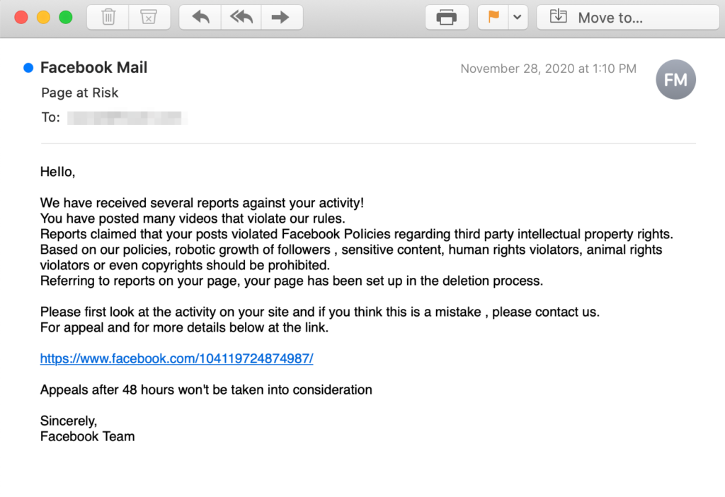
(Figure 1b: Facebook phishing scam)

Prevention & Protection Tips:
- Be cautious of unsolicited emails and messages.
- Do not click on suspicious links or download unexpected attachments.
- Verify the sender’s email address.
- Use 2-Factor Authentication (2FA) wherever possible.
- Install anti-phishing toolbars and browser protection extensions.
- Educate users through cybersecurity awareness programs.
- Regularly update your systems and software.

2. Ransomware
Ransomware is a type of malicious software (malware) that encrypts files on a victim’s device, making them inaccessible. The attacker then demands a ransom, usually in cryptocurrency (like Bitcoin), in exchange for a decryption key.

Key Characteristics of Ransomware:
- Encrypts important files or entire systems.
- Displays ransom note demanding payment.
- Often spreads via phishing emails, malicious downloads, or software vulnerabilities.
- May also steal data before encryption (double extortion).

Types of Ransomware:
- Crypto Ransomware: Encrypts files (e.g., WannaCry, Maze).
- Locker Ransomware: Locks access to the device without encrypting data.
- Scareware: Fake alerts urging payment for fake threats.
- Doxware: Threatens to leak stolen data publicly if ransom isn’t paid.

Real-World Examples of Ransomware Attacks:
- WannaCry (2017):
  - Spread: Exploited a vulnerability in Windows (EternalBlue).
  - Impact: Affected over 200,000 computers in 150 countries including UK’s NHS.
  - Ransom: Demanded Bitcoin for decryption.
- NotPetya (2017):
  - Disguised as: A software update from a Ukrainian company.
  - Impact: Hit global companies like Maersk, Merck, FedEx.
  - Damage: Estimated over $10 billion in losses.

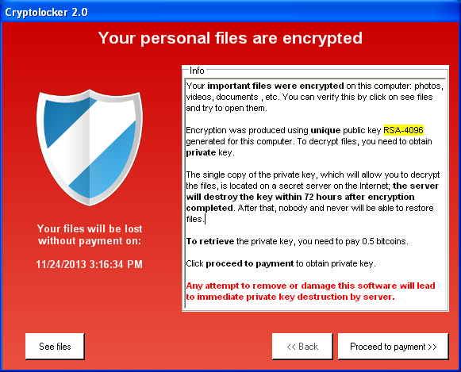
(Figure 2a: Cryptolocker)
CryptoLocker, an encrypting Trojan horse, occured from 5 September 2013 to late May 2014.
The Trojan targeted computers running Microsoft Windows, propagating via infected email attachments and via an existing Gameover ZeuS botnet.
Once activated, the malware encrypted files stored on local and mounted network drives using RSA public-key cryptography, with the decryption key stored on the malware's control servers.
CryptoLocker then displayed a ransom message offering to decrypt the data if a Bitcoin or prepaid cash voucher payment was made by a stated deadline. It employed social engineering to create a sense of urgency, threatening to delete the decryption key if the deadline passed.

How It Works:
- Ransomware is delivered via email or infected websites.
- It encrypts files and locks the system.
- A ransom note is displayed demanding payment for decryption.

Prevention & Protection Tips:
- Back up data regularly (offline and in the cloud).
- Use updated antivirus software and enable real-time protection.
- Patch vulnerabilities with regular software updates.
- Don’t open unsolicited attachments or links in emails.
- Disable macros in documents from unknown sources.
- Implement Network Segmentation to limit malware spread.
- Use Application Whitelisting to prevent unauthorized software.

3. Supply Chain Attack
Supply Chain Attacks occur when cybercriminals target trusted third-party vendors or software providers to infiltrate larger organizations. Instead of attacking directly, they exploit vulnerabilities in a partner’s infrastructure, software, or update mechanisms.

Key Characteristics of Supply Chain Attacks:
- Compromise trusted software/code providers.
- Malicious code is inserted into updates, plugins, or hardware components.
- Difficult to detect due to trusted nature of source.
- Allows widespread access to many downstream victims.

Types of Supply Chain Attacks:
- Software Supply Chain Attack: Compromising software updates (e.g., SolarWinds).
- Hardware Supply Chain Attack: Inserting backdoors in hardware components.
- Third-Party Vendor Attack: Using insecure vendors or cloud services to gain access.

Real-World Example: SolarWinds Attack (2020)
- Targeted Software: Orion IT monitoring platform by SolarWinds.
- What Happened: Hackers inserted malware (SUNBURST) in software updates.
- Victims: Over 18,000 organizations including U.S. Treasury, Microsoft, and FireEye.
- Attribution: Believed to be state-sponsored (APT29/Russian group).
- Impact: Massive data breaches, loss of trust, national security concerns.

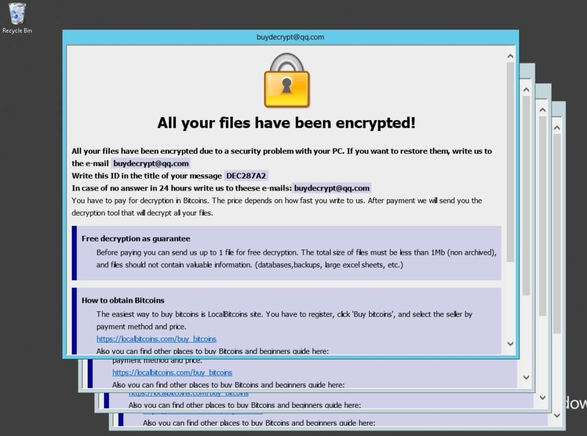
(Figure 3a: Supply chain attack)

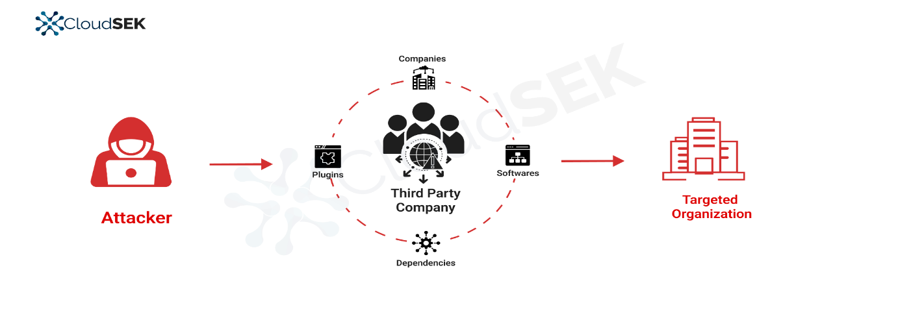
(Figure 3b: CloudSEK Monitoring supply chain)

Prevention & Protection Tips:
- Conduct due diligence on vendors and their security practices.
- Use code-signing certificates for software authenticity verification.
- Implement Zero Trust Architecture (trust nothing, verify everything).
- Monitor network traffic and system logs for anomalies.
- Enforce least privilege access for third-party integrations.
- Regularly audit and review supply chain dependencies.
- Use endpoint detection and response (EDR) tools.

Conclusion: Understanding cyberattacks like phishing, ransomware, and supply chain attacks is crucial in today's digital world. These threats exploit both technical vulnerabilities and human behavior, making awareness and proactive security measures essential. Regular training, system updates, and strong security practices can significantly reduce the risk of falling victim to such attacks.

